PROJECT ON WEB DESIGNING



# ACKNOWLEDGEMENT

First and foremost, we wish to express our gratitude to the Almighty god for the abundance of wisdom and presence throughout the execution of our project.

We are taking opportunity to express our sincere thanks to our Deputy Director Mr. Sojan Jose with whose permission made this project. We here by acknowledge, with deep sense of gratitude the very valuable advice and guidance of our teacher Mr. Achu Sivadasan, Ms. Deepaca Reglaqoz Fedisha and all other teachers for without whose help it would have impossible to complete this project work. We also express our thanks to all other members in the Institution.

Last but not the least we would like to thank the encouragement given by our classmates and others teachers for supporting in hundred title ways that means a lot.

This leaf of acknowledgement would not be complete without special thanks for their normal support encouragement and love, which enabled to successfully bring out this project.



**TABLE OF CONTENTS**

1. **INTRODUCTION**
2. **IMAGES ON WEBPAGES**
   1. **LOGIN**
   2. **SIGN UP**
   3. **CATEGORY**
   4. **SEARCH**
   5. **ABOUT**
3. **SOURCE CODE**
4. **CONCLUSION**
5. **BIBLIOGRAPHY**



# 1.INTRODUCTION

Book Hub is an online website where customers can read book through it. The user must need to create an account before logging into the website. They can choose different category of stories using a single click. And it is user friendly website where the user can access it on any time and from anywhere. Most of persons are not interested to carry book in their bag, this website is a solution for their problems. We only need a phone to open library, they let you travel by reading books without moving your feet.



# 2.IMAGES OF WEB PAGES

* 1. **LOGIN**

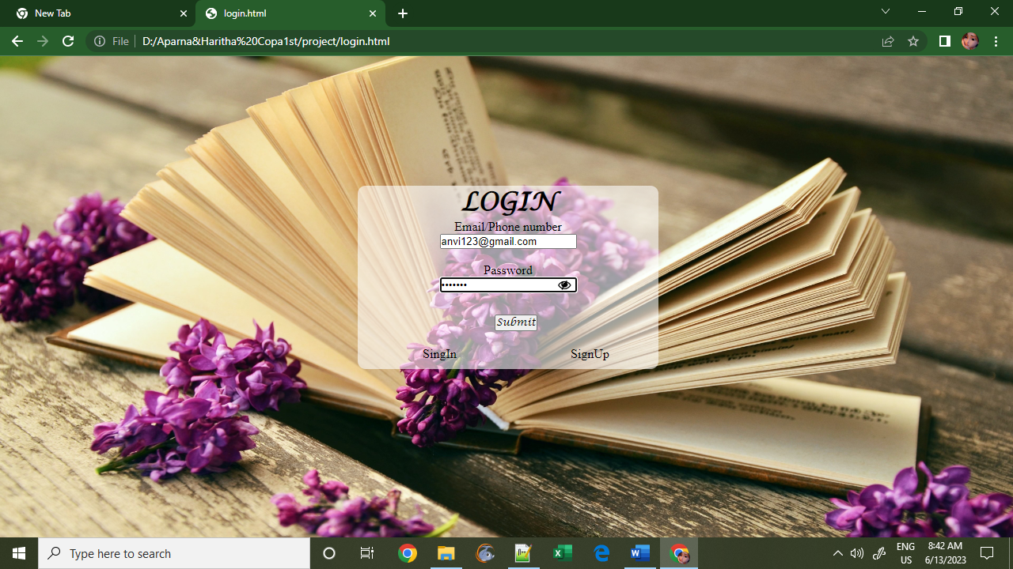

**2.2 SIGN UP**

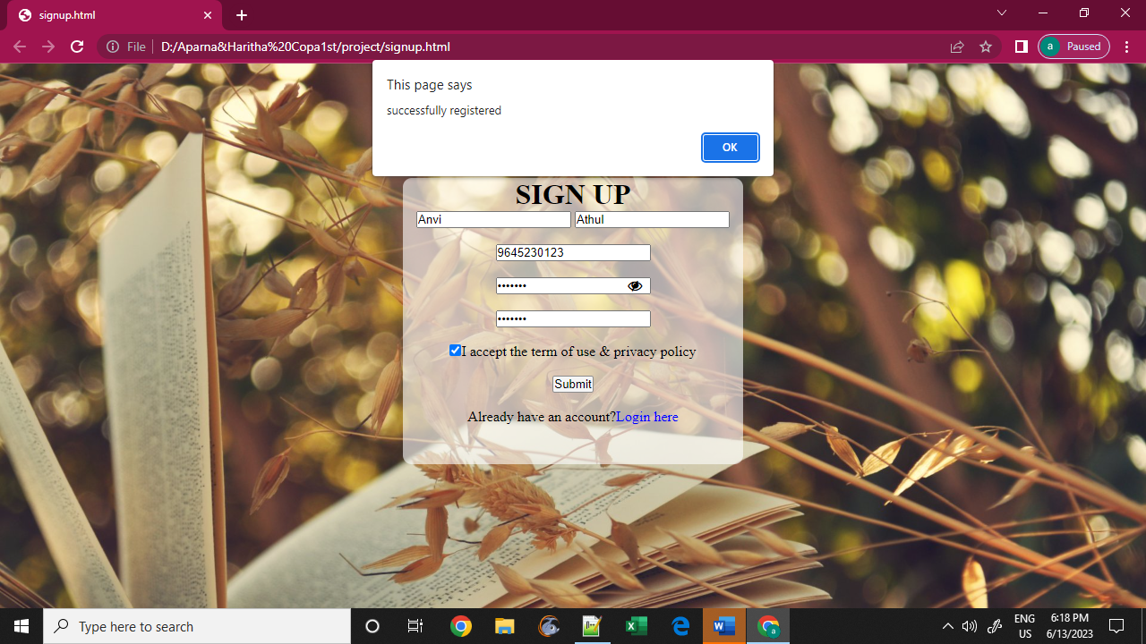



**2.3 HOME PAGE**

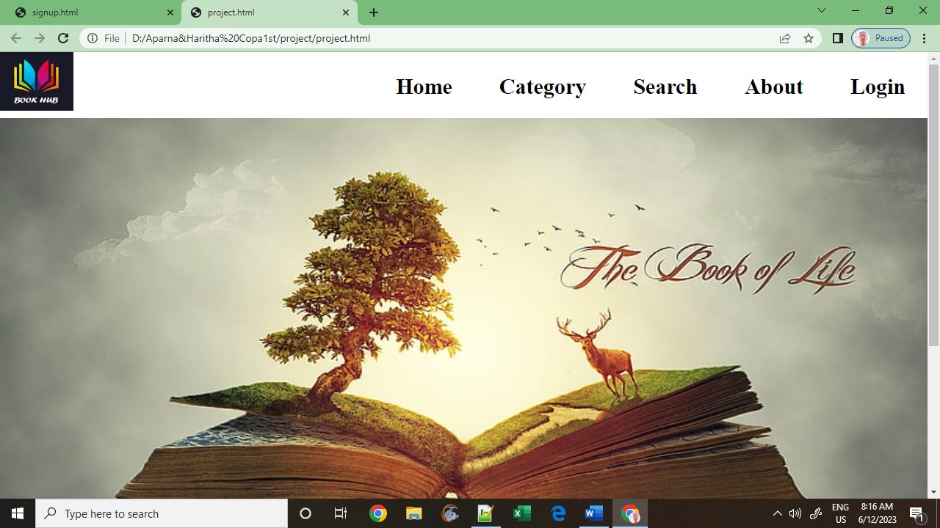

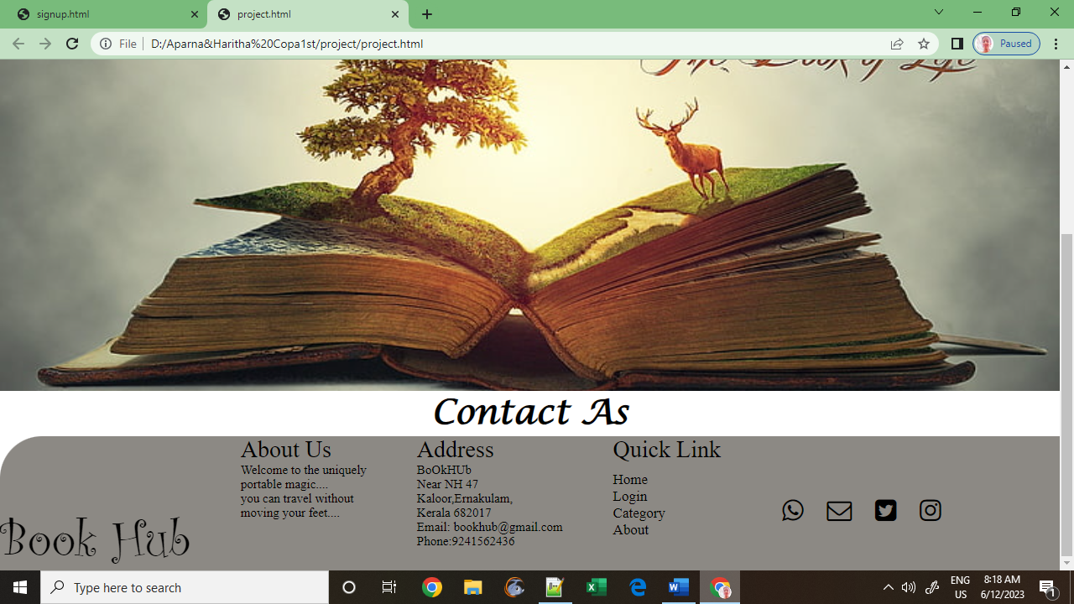



**2.4 CATEGORY**

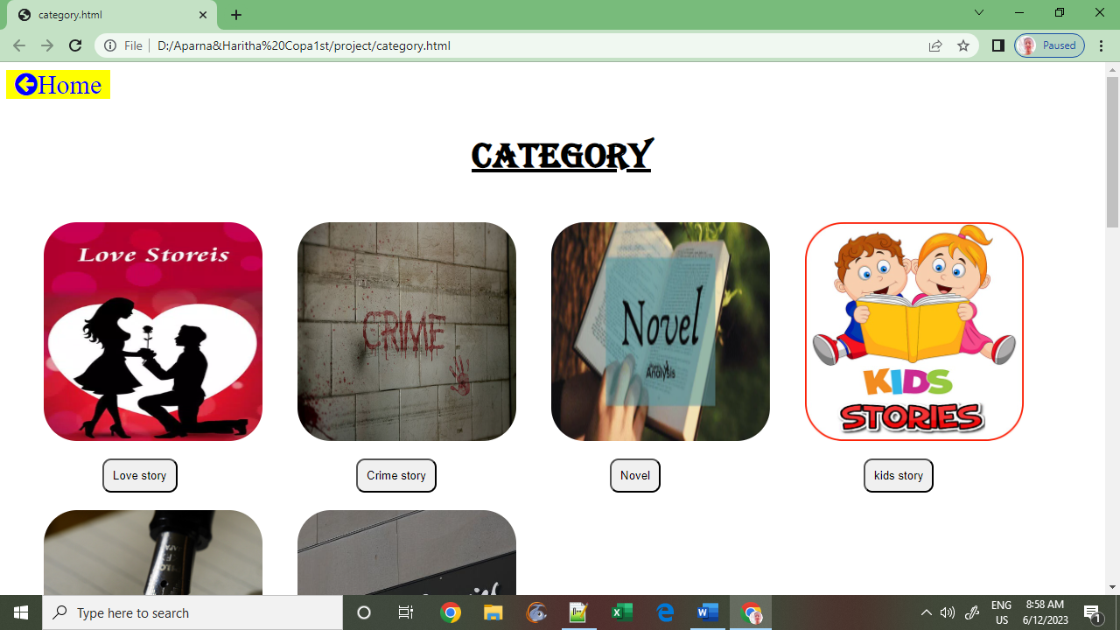

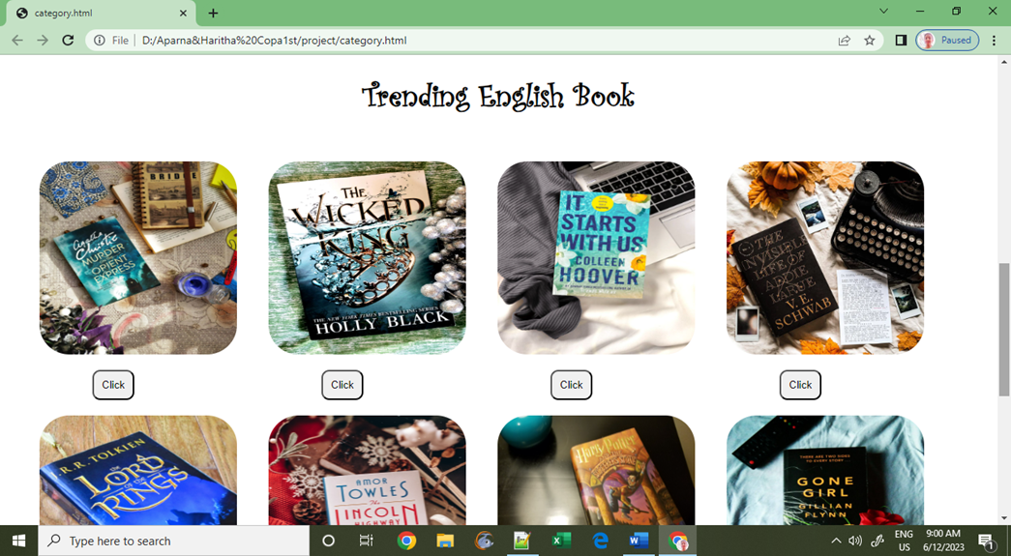



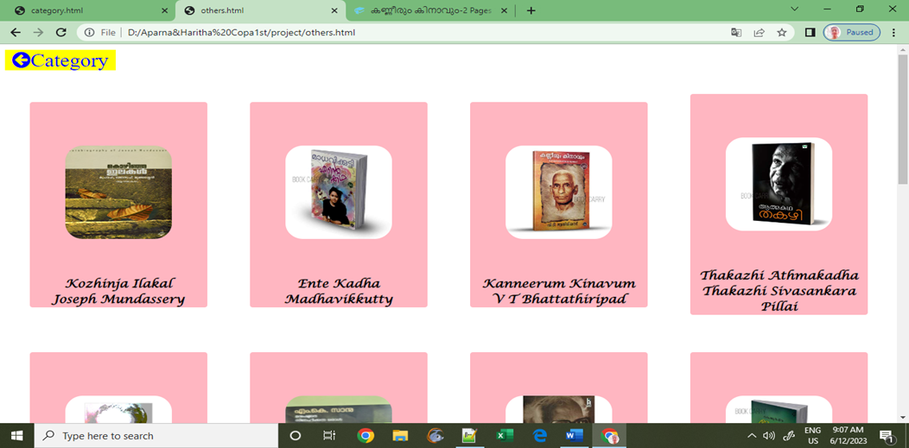

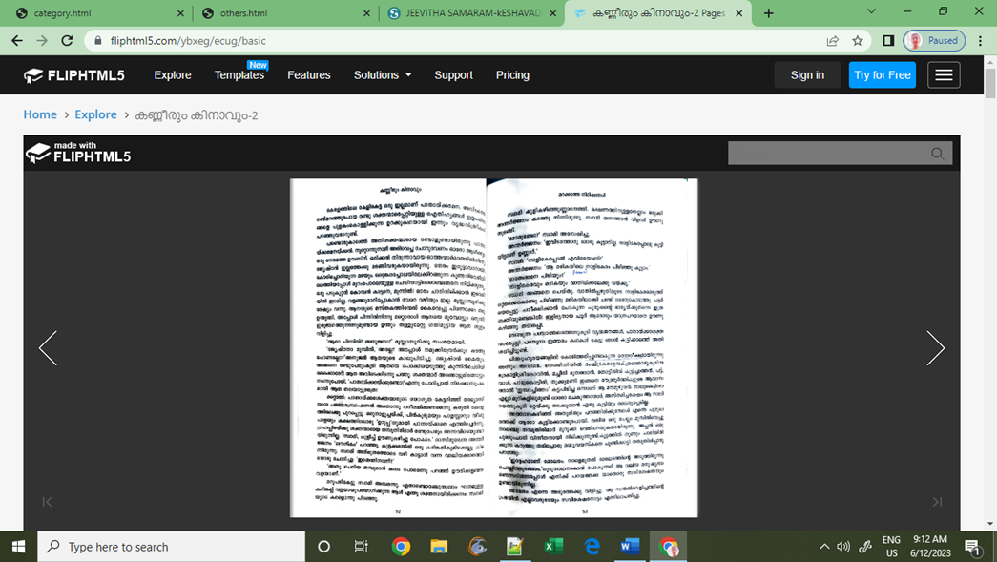

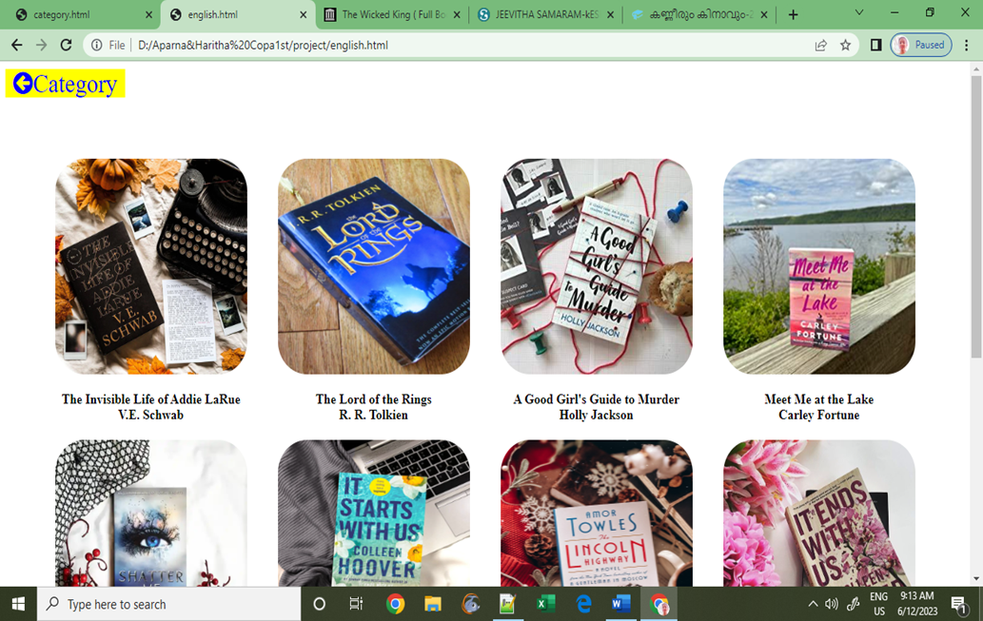

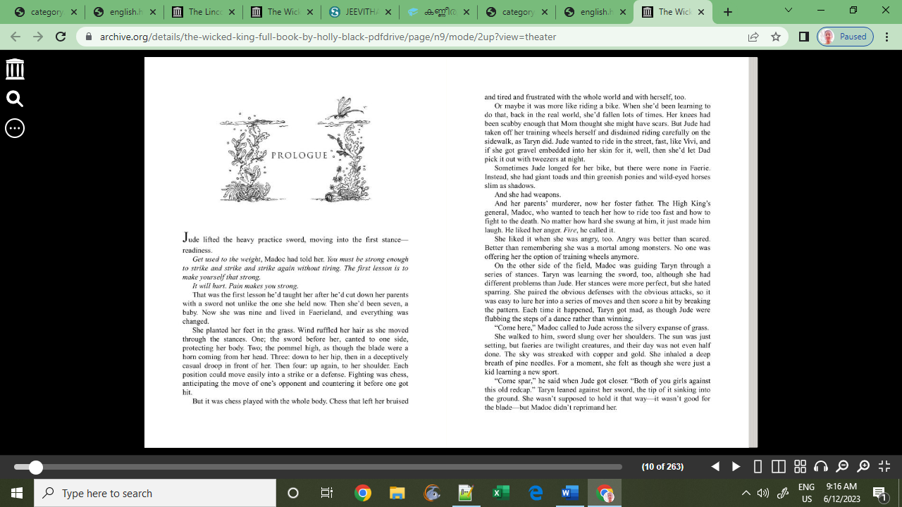



**2.5 SEARCH**

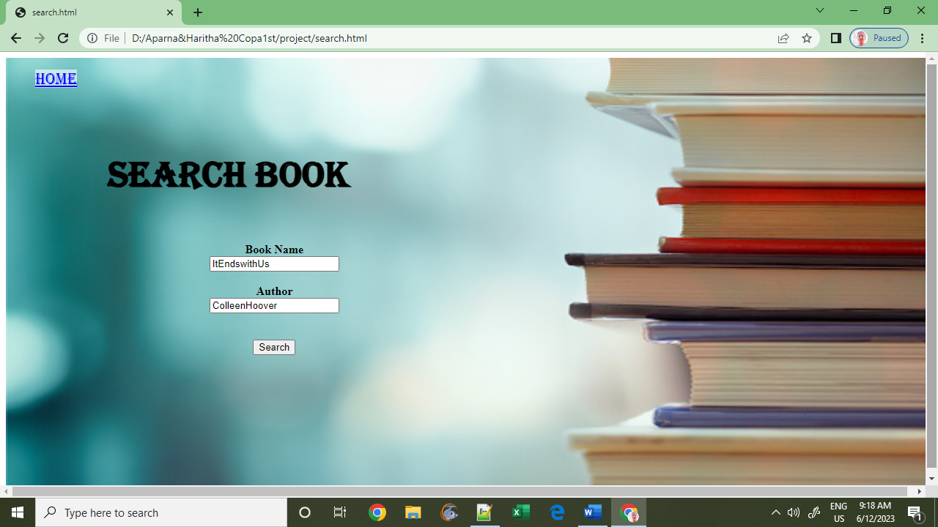

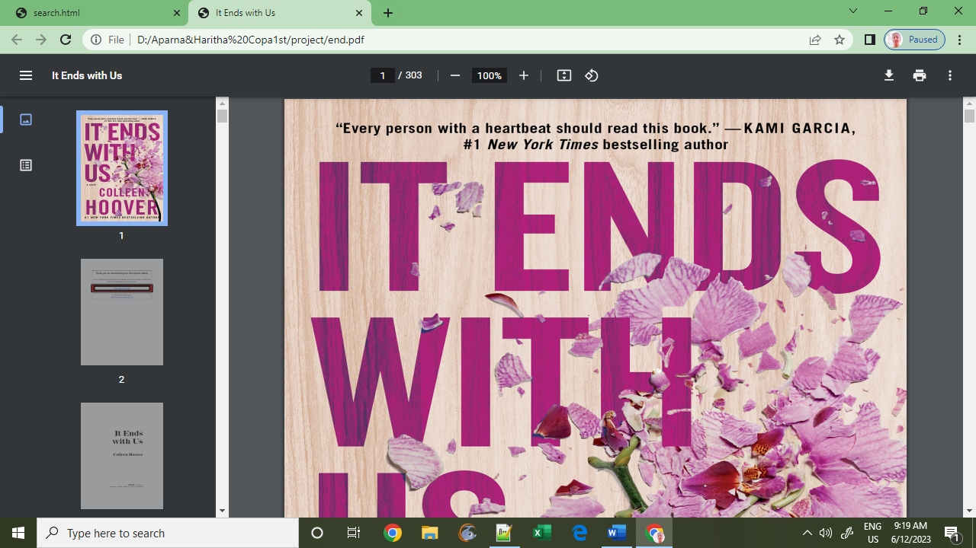



**2.6 ABOUT**

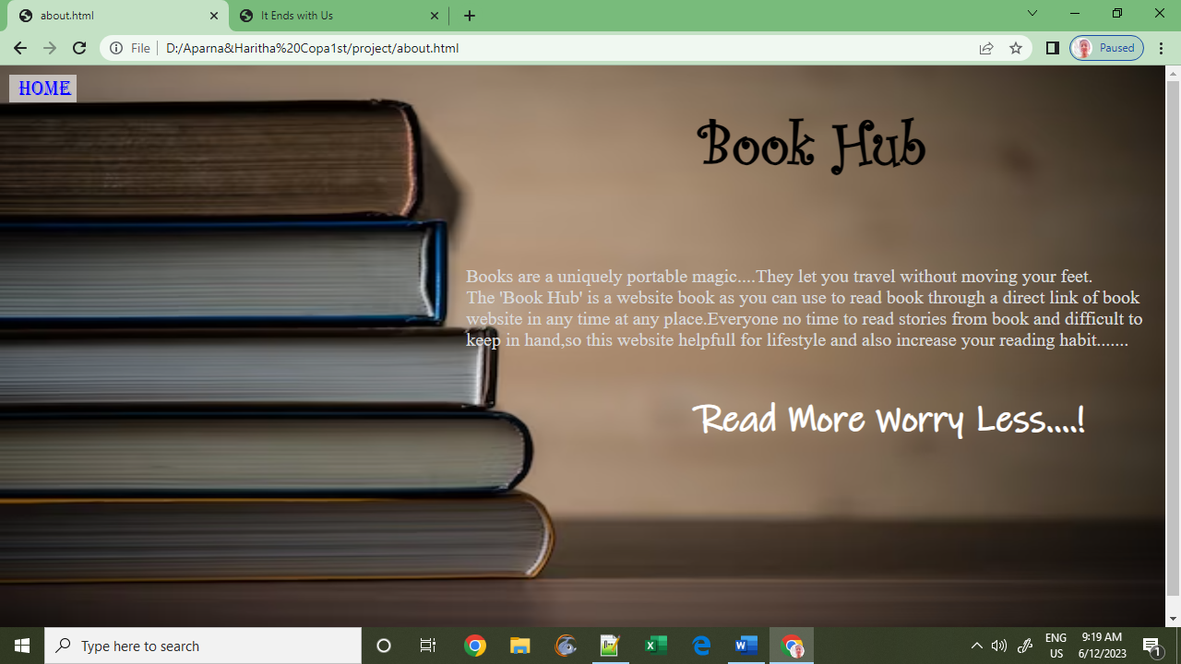

# 3.SOURCE CODE

**HOME PAGE**

<html>

<head>

<link rel="stylesheet" href="https://cdnjs.cloudflare.com/ajax/libs/font-awesome/4.7.0/css/font-awesome.min.css">

<link rel="stylesheet"href="code.css">

</head>

<body>

<div>

<div class="main">

<img class="logo" src="logo1.jpg">

<ul>

<li class="h"><a href="project.html"class="c">Home</a></li>

<li class="h"><a href="category.html"class="c">Category</a></li>

<li class="h"><a href="search.html"class="c">Search</a></li>

<li class="h"><a href="about.html"class="c">About</a></li>

<li class="h"><a href="login.html"class="c">Login</a></li>

</ul>

</div>

</div>

<img class="bck" src="life.jpg">

<h1 class="con">Contact As </h1>

<div style="display:flex;background-color:#8C8984;border-top-left-radius:50px;">

<div class="Hub">Book Hub</div>

<div class="aoq">About Us

<p class="py">Welcome to the uniquely<br>portable magic....<br>you can travel without<br>moving your feet....</p></div>

<div class="aoq">Address<p class="py">BoOkHUb<br>Near NH 47<br>Kaloor,Ernakulam,<br> Kerala 682017<br>Email: bookhub@gmail.com<br>Phone:9241562436</p></div>

<div class="aoq">Quick Link<div style='height:10px'></div>

<a href="project.html" class="ps">Home</a><br>

<a href="login.html" class="ps">Login</a><br>

<a href="category.html" class="ps">Category</a><br>

<a href="about.html" class="ps">About</a><br>

</div>

<div class='icon'>

<i class="fa fa-whatsapp" id="wht"></i>

<i class="fa fa-envelope-o" id="env"></i>

<i class="fa fa-twitter-square" id="twi"></i>

<i class="fa fa-instagram" id="ins"></i>

</div>

</div>

</div>

</body>

</html>



**CSS CODE**

*{margin:0;padding:0;}

.bck{width:100%;height:100%}

.main{background-color:rgb(255,255,255,0.6);display:flex;height:90px;}

.logo{width:100px;height:80px;}

.h{display:inline-block;margin:30px;font-size:30px;font-weight:bold;}

ul{flex:1;text-align:right;}

a{text-decoration:none;color:black;}

.c:hover{text-decoration:underline;}

.bck2{width:100%;height:100%}

.lo{font-family:Lucida Calligraphy;}

.but{font-family:Lucida Calligraphy;}

form div{width:100%;display:flex;justify-content:space-around;padding:10px}

.form{position:absolute;bottom:35%;right:35%;background-color:rgb(255,255,255,0.6);width:380px;height:200x;top:100%px;border-radius:10px;}

.sign{color:black;}

.sign:hover{text-decoration:underline;}

.al{color:black;text-decoration:none;}

.loh{color:blue;}

.loh:hover{text-decoration:underline;}

.book{background-image:url(ook.jpg); background-repeat:no-repeat;background-size:cover;}

.ha{background-color:rgb(255,255,255,0.6);width:380px;height:320px;margin-top:10%;border-radius:10px;}

.g{font-family:Microsoft YaHei Light;}

.g:hover{text-decoration:underline;}

.bk{width:300px;height:300px;border-radius:20px;padding:20%}

.in{font-size:18;text-align:center;padding-top:10px;font-family:Lucida Calligraphy;}

.ck{width:150px;height:200px;padding-left:20%;}

.dk{width:300px;height:300px;}

.bu{margin-left:90%;}

.abo{width:100%;height:100%;position:relative;}

.l{position:absolute;top:40px;left:60%;font-family:Curlz MT;font-size:65px;}

.ph{position:absolute;bottom:300;left:40%;font-family:Times New Roman;font-size:20px;color:#d9d9d9;}

.re{position:absolute;top:360;left:60%;font-size:40px;color:white;font-family:Ink Free;}

.ba{width:100%;height:140%;position:absolute}

.cate{font-size:20px;font-family:Algerian;text-decoration:underline;padding-left:20px;text-align:center;margin-top:50px;}

.lv{padding:20px;height:250px;width:250px;border-radius:20%;}

.lve{padding:10px;border-radius:10px;margin-left:30%;}

.d1{margin:40px;font-family:Curlz MT;font-size:20px;text-align:center;}

.bk{width:150px;height:150px;border-radius:30%;}

.hk{width:150px;height:150px;border-radius:20px;}

.k{text-decoration:none;}

.k:hover{text-decoration:underline;}

.pn{margin-left:50px;font-family:Lucida Calligraphy;padding-left:350px;}

.mk{width:180px;height:180px;margin-left:90px;}

.pn:hover{text-decoration:underline;}

.sk{width:200px;height:250px;border-radius:50%;}

.sn{margin-left:50%;font-family:Lucida Calligraphy;padding-top:20%;}

.hn{margin-left:60%;font-family:Lucida Calligraphy;padding-top:10%;}

.sn:hover{text-decoration:underline;}

.hn:hover{text-decoration:underline;}

.con{text-align:center;font-family:Lucida Calligraphy;font-size:40px;}

.hub{font-size:60px;font-family:Curlz MT;margin-top:80px;}

.aoq{font-size:28px;font-family:Times New Roman;padding-left:60px;}

.py{font-size:15px;}

.ps{font-size:17px;padding-top:10px;}

.ps:hover{text-decoration:underline;}

.icon{font-size:30px;padding-left:5%;margin-top:5%;}

.fa{margin:10px;position:relative}

.psw{position:relative;}

#wht:after{content:'9241562436';

height:40px;

font-size:16px;

position:absolute;

top:-18px;

left:0;

visibility:hidden;

}

#wht:hover:after{visibility:visible}

#env:after{content:'bookhub@gmail.com';

height:40px;

font-size:16px;

position:absolute;

top:-18px;

left:0;

visibility:hidden;

}

#env:hover:after{visibility:visible}

#twi:after{content:'bOoKhUb123';

height:40px;

font-size:16px;

position:absolute;

top:-18px;

left:0;

visibility:hidden;

}

#twi:hover:after{visibility:visible}

#ins:after{content:'@BoOkHuB';

height:40px;

font-size:16px;

position:absolute;

top:-18px;

left:0;

visibility:hidden;

}

#ins:hover:after{visibility:visible}

#eye,#o-eye{position:absolute;left:54%;bottom:56.4%;}

#ey,#v-eye{position:absolute;left:64%;top:46%;}

.df div{display:flex;flex-direction:column;align-items:center;justify-content:center;flex-basis:20%}

.demo div:hover{box-shadow:1px 5px 5px 3px rgb(00,00,00,0.5);transform:translateY(-20px);transition:0.2s;}

.demo{margin:20px;}

.demo div{height:350px;width:250px;padding-top:20px;}

.font{font-size:30px;color:blue;background-color:yellow;margin-left:11%;}



**4.CONCLUSION**

The “Book Hub” has been developed to override the problems prevailing in the practicing manual system. This software is supported to eliminate and in some cases reduce the hardships faced by this existing system. Moreover this system is designed for a particular need to carry out operation in a smooth and effective manner.

The project shows the flow of each and every transaction which is being carried out by the desired user successfully thus giving him the desired result. This website provides easy to read book at any time in any where. Through this website user can select different categorys of book and the users can enter a uniquely portable magic.

.

# 5.BIBLIOGRAPHY

## <https://www.w3schools.com/>

## <https://openlibrary.org/>

## <https://www.goodreads.com/>

## <https://www.pratilipi.com/>





